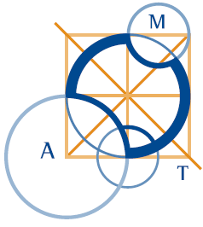
AUSTRALIAN Mathematics Competition 2014

Dear NNPS Parents,
The annual AMT Mathematics Competition will take place on Thursday 7 August for interested students in year 3-6. The fee for the competition is $6.00.
The aim is to give students an opportunity to discover talent in mathematics. Students are asked to solve thirty problems in 60 minutes. The earliest problems are very easy, all students should be able to attempt them. The problems get progressively more difficult until the end, when they are challenging to the most gifted student.

If you would like to register your child, please print the attached form/ collect a form from the 5T classroom or the office/ print out the form from the school website and return to school office gold box with your $5.50 enclosed before the end of Term One.

Kind Regards,
Sophie Town
Competition Coordinator

